

**Cognizant Technology Solutions**

**Marketing Strategy Research Report**

**Course Number: BU.450.710.81.FA13**

**Prepared by: “Drucker’s Drones”: John Ellis, Ji Leo Li, Matthew Koch, Vinita Bhaskar**

**Date: December 5th, 2013**



Table of Contents

Executive Summary 3

Current Business Situation 3

The Clients 4

Cognizant’s Competition 5

The SMAC Stack 6

Context: Global Company, Global Challenges 7

Collaborators 8

Firms’ Objectives 9

Marketing Strategy and Implementation 10

STP 10

4 P’s 10

Analysis and Evaluation of the Marketing Strategy 12

The Future of Cognizant 12

References 16

Appendices 18

Executive Summary

Founded in 1998 from an offshoot hybrid Indian-American company, Dun & Bradstreet Satyam Software, Cognizant Technology Solutions Corporation (CTS) was always an atypical Indian IT firm. (Eccles, 2011, p.2) CTS provides information technology (IT), business consulting, ecommerce, enterprise information management, and outsourcing services for the healthcare, financial services, manufacturing, retail, and logistics industries. (Marketline Advantage, 2013, p.4) It comprises one part of India’s IT services sector, also known as ‘SWITCH,’ along with Satyam, Wipro, Infosys, TCS, and HCL. (Moorthi, 2011, p.1) The company reported 2012 revenues of approximately US $7.345 billion (Cognizant 2013, n.p.), which is up 20% year-over-year. CTS has made remarkable progress within the last year, with profits rising 19.2% since last year. Of particular note is the fact that CTS clients in financial services and manufacturing spent 6.5% and 8.4% more than they did in Q3 of 2012, respectively. (Forbes, 2013, n.p.)

It can be deduced that CTS is not simply adding new clients but also finding ways to retain and grow their business simultaneously. This paper will highlight key aspects of CTS’s marketing strategy up to 2012, how the firm is performing relative to competitors, CTS’ objectives, an analysis of current strategies, and will conclude with a look to the future for this innovative firm. A key driver behind an IT company’s marketing strategy is clients’ product and growth plans for technological development. IT companies must anticipate clients’ product requests and requirements. CTS is an intriguing success story in an ever-shrinking IT marketplace. From a macro-perspective, IT companies are moving towards developing in-house solutions for many of the products CTS currently offers. However, this firm continues to not simply retain but expand both its client roster and revenues.

CTS’s core strategy has helped the firm gain market share and positioning ahead of its competitors. Using innovative, disruptive, and ‘blue ocean’ positioning, CTS has expanded revenue and growth for the past 15 years. Their blue ocean strategy incorporates vertical reinvestment, a unique point of differentiation when the firm reorganized in 2002, and other disruptive strategies, resulting in exponential growth for this company. (Moorthi, 2011, p.1) By analyzing customer wants and needs within these verticals, CTS is staying ahead of the consumer curve and focusing on developing existing clients.

Current Business Situation

*CTS in 2012*

In 2012, CTS launched the new “SMAC Stack”, a fifth generation IT architecture solution. Since it’s inception as a captive unit of Dun & Bradstreet Corporation in 1994, the firm had been a consistent innovator in the IT, consulting, and business processing outsourcing (BPO) services sectors. (Eccles, 2011) In the last twenty years, several internal and external shifts have occurred. Between 1996-1997, CTS emerged as an independent company with 575 employees and approximately $12 million in revenue. By 2012, the firm had 156,700 employees and revenue ballooned to $7.3 billion. Despite the firm’s monumental success, the IT industry is changing. CTS’s customers have higher expectations, competition is intensifying, and the industry on the whole is shrinking. CTS has sustained remarkable success for the past fifteen years due to its core strategy. By describing CTS’s 5 C’s, or clients, competitors, collaborators, context, and company, the firm’s product, sales, and marketing strategies can be analyzed. This paper will first analyze CTS as a company, its clients, competitors, and finally, current collaborators and context.

The Clients

In 2012, CTS had 821 customers, up from 785 the year before. These customers were all medium-to-large businesses that provided revenues between $5-50 million individually. Clients are distributed amongst four primary industries: financial services (41.3%), healthcare (26.3%), manufacturing retail and logistics (20.4%), and information and communication companies (12%). (Cognizant, 2012-13, n.p.) CTS’s major clients include firms such as: United Healthcare, AstraZeneca, and Kimberly-Clark. (Eccles, 2011, p. 9)

CTS was listed as one of India’s Top 5 IT service providers by Gartner in 2012 and held about 0.8% of the market, up from 0.7% the year before. (Gartner, 2013, n.p.) CTS is famous for its highly skilled programming team, primarily based in India. (Cognizant, 2013, n.p.) The firm began its meteoric rise to become a top BPO company by assisting global businesses to develop, integrate, and support IT solutions to increase efficiency and effectiveness of their products . Early in the firm’s history, programmers and software project teams were tasked with shoring up computer systems against Y2K-related threats, primarily in North America. (Eccles, 2011, p. 2) Clients continued to ask more of CTS, and the firm began to develop software solutions for a growing number of business process and workflow issues. These deliverables turned into opportunities for CTS to delve into IT solutions for a wide array of business segments, including human resources, finance, and healthcare.

Recognizing growth in specific business sectors, beginning in 2002, CTS began to reorganize by industry vertical with a focus on four primary industry groups: financial services, healthcare, manufacturing retail and logistics, and information and communication industries. Each vertical benefitted from hiring industry experts to oversee IT consulting and technology integration efforts. (Cognizant, 2011, n.p.) Additionally, the firm organized horizontal project teams to deliver services to clients. In 2007, CTS set out to prove “two heads are better than one” with their “Two-in-a-Box” management structure. Two-in-a-Box positioned client-facing CTS employees at client sites to gather project requirements, integrate systems, and train client employees on the systems use while another group, primarily in India, did a majority of the programming and more technical work. That same year, CTS launched “Cognizant 2.0”, or “C2,” a global application and software connectivity tool that helped connect internal employees and external software users. C2 was developed as CTS recognized the power and possibilities of an interconnected web as well as the availability of inexpensive computing power for business applications. (Eccles, 2011)

While CTS’s customers were well distributed amongst a number of industries, there was a significant lack of geographical variety. In 2012, 79.4% of CTS’s customers were from North America, with a large majority from the United States. The remaining clients were from Europe (16.3%) or the Asia-Pacific region (4.3%). During the years leading up to 2012, CTS noticed a trend regarding the geographic location of its customers. The percentage of clients based in North America and the Asia-Pacific region had grown, while the amount of European clients was shrinking. However, overall revenue managed to increase by 20.1% in only one year. (Cognizant, 2012-13, n.p.) External market factors, such as the Eurozone recession and subsequent economic crisis relayed strategic pressure on CTS’s European division to retain client business.

CTS’s largest clients were also beginning to represent smaller portions of overall revenue. In 2012, the top ten customers represented 25% of revenues, a reduction from 30.3% in 2010. Customers were also beginning to structure contracts differently. A larger percentage (33.1% in 2012 compared to 31.5% in 2010) preferred a fixed-bid system, in which a project is paid for through completion, instead of a billable time system. (Cognizant, 2012-13, n.p.)

CTS’s customers expected IT solutions, integration services, and business consulting that would increase efficiency and effectiveness while driving down costs and increasing profits. Clients also expected a quality product that performed reliably and included responsive technical support at a competitive price. (Cognizant, 2013, n.p.) In the CTS 2012 Annual Report, the firm believed its key drivers of success included performance, reliability, and quality technical support. Additionally, referrals and a well-developed recruiting, training, and retainment system were credited as helping to deliver successful solutions and services while remaining an employer of choice. Despite these positive elements in CTS’s strategic focus, several blind spots existed including a focus on a relatively narrow band of customers and industries. For example, the data-rich energy and infrastructure industries have never been supported by CTS.

Cognizant’s Competition

CTS serves a small but growing segment of the IT consulting market at just 0.8% (Gartner, 2013) and has a number of much larger and wealthier competitors including Accenture, Cap Gemini, Computer Sciences Corporation, Genpact, HCL Technologies, IBM Global Services, Infosys Technologies, Tata Consultancy Services, and Wipro. Additionally, CTS competes with small, local companies offering similar services. (Cognizant, 2013) India’s ‘SWITCH’ companies are simultaneously moving away from a strategy of building incremental IT solutions and towards developing disruptive technologies. This paper will address the future of CTS and their blue ocean initiatives towards the end. It is important to note that the firm’s competitive prowess is linked to its future strategy. (Moorthi, 2011, p.1) CTS is operating in an established marketplace, where clients’ critical mass was reached

Competition is not solely from the IT sector. CTS also faces competitive challenges from traditional consulting firms, such as McKinsey, that are launching their own applications to support business processes and decision-making. Many application designers and equipment manufacturers are also beginning to assemble their own solutions and service departments. Additionally, in-house IT departments that many large companies have established create competition for CTS. (Gartner, 2013, n.p.)

Beginning in 2002 and 2003, the firm focused on vertical alignment of their core competencies in lieu of a geographic distribution strategy. (Cognizant, 2011, p.3) This differentiated CTS from competitors. CTS divided up employees from various departments and assigned them to one of four internal verticals. The firm dedicated support to these verticals through ‘horizontal’ technology offerings such as C2, a Web 2.0 delivery platform designed to enhance teamwork and collaboration with the client. An additional positive with the development and implementation of C2 involved location. (Eccles, 2011, p.3) C2 enabled the company to connect teams and clients worldwide and assisted the company in dealing with strains from its rapid growth internally. The team conducted interviews with Max Han and Ravi Gururaj, two former project managers at CTS. Mr. Gururaj shed some insight into the geographic strategy behind CTS’s expansion:

*“The Philippines is a popular American destination for call centers. Major banks (such as Citibank and Barclays) outsource development to China and Singapore. Interactive ad agencies (such as Razorfish and HUGE) have development centers in Brazil. Large conglomerates like IBM and Siemens outsource to internal development centers in China and Canada. Many London-based companies outsource to Ireland and Eastern Europe. Many Korean and Japanese companies outsource to Chinese IT firms, such as Pactera.*

CTS is facing increasing competition on both geographic and product fronts; companies are beginning to outsource development to surrounding countries, and governments are now competing with India and other established BPO markets for business. CTS is gaining market share due to its innovations and disruptive technologies. The firm is not simply developing incremental IT solutions but is creating a blue ocean for mobile, nimble technology solutions for its clients. The SMAC Stack is an example of such innovation.

The SMAC Stack

In 2012, recognizing that technological capabilities and consumer business needs had changed again, CTS launched the SMAC Stack (social, mobile, analytics, and cloud). SMAC is a powerful new tool to help manage the tremendous amount of data created and used daily globally by clients and consumers alike. As workplaces organized projects around digital project walls and relied on flexible work groups, client needs began to shift away from formal and stationary workplaces to a mobile and social environment. SMAC is CTS’s workable solution for this new trend. Increasingly, project coordination and collaboration is shifting away from the desktop and towards a highly mobile, personal, and always connected business atmosphere. Due to the rising levels of mobile and social content being created and consistently decreasing cost of outsourcing data storage means that, firms are moving away from only storing data externally. Companies are now also using entirely web-based IT applications and services, commonly referred to as cloud computing. The rapid rise in the amount of data, known as big data, is creating more sophisticated methods for analytics, a necessary rug in the data storage ladder. Through the SMAC Stack product and overarching service offerings, CTS is offering clients essential tools to analyze big data. (Cognizant, 2013, n.p.)

*Social*: Increasingly, firms were interacting with both external and internal employees and consumers through social network channels. CTS developed SMAC related offerings to help clients navigate the sometimes-complex social world to gather the information needed to make informed decisions while at the same time developing virtual workplaces for project and work groups to interact.

*Mobile*: Mobile devices had long since outgrown the simple phone feature and instead had many of the same features as laptops and some desktop computers. Increasingly users were also using tablets and other small computers to access files, check email, and perform web searches. (StatCounter, 2013, n.p.)

*Analytics*: With increasing amounts of data, global companies found that the need to employ ever more advanced means to determine user and consumer needs and requirements became a necessity. Analytics allowed firms to analyze text, access patterns, and compare user behaviors in addition to the standard statistical applications traditionally performed in business operations.

*Cloud*: The availability and relatively low cost of storing information and applications help firms to manage a number of challenges and reduce costs. First, by storing files and applications at a web accessible point resulted in a reduction in costs for critical system support and operations staff as well as reduced the complexity of updating and launching applications. In many cases, cloud based applications also reduced the threat from malicious hacking attempts by centralizing data and limiting access points from physically connected devices.

Context: Global Company, Global Challenges

CTS continues to face significant challenges due to the firm’s global positioning set against contradictory national laws, tax structures, immigration legislation, and currency fluctuations. While CTS reports its earning in dollars, the fluctuation of the Indian rupee has significant impact on the company’s operations. The movements of company assets between global business sections are also challenged by repatriation taxes. CTS’s use of India’s Special Economic Zones (SEZ) exposes the firm to sudden and irreversible taxes increases within India. Anti-bribery legislation, such as the United States’ Foreign Corrupt Practices (FCPA), has the potential to threaten CTS if any employee or subcontractor were to break the law. Finally, availability of qualified and talented employees is limited and competition for workers from India and the Philippines in particular is intense. (Marketline Advantage, 2013, n.p.)

CTS’s business model relies heavily on both onshore and offshore teams. Onshore teams work directly with clients to develop and deliver IT solutions and services. In the United States, CTS’s primary market, anti-outsourcing laws as well as changes in the way that work visas are issued can have significant and adverse effects on the firm’s profit margin. In particular, issuance of the H-1B visa, which permits a worker to remain in the United States for up to six years, is limited to 65,000 with an additional 20,000 for advanced degree holders per annum. Similarly, the L-1A and L-1B permit are restricted for employees with specific company knowledge or specialized skills. Workers with an L-type visa are not allowed to be supervised from a non-employer of their firm per United States immigration laws. In the consulting and IT industries, this could be interpreted as working for the client instead of your specified firm; in these situations, CTS may be liable for strict fines. Laws in the United Kingdom present a slightly different threat: in the UK, if a foreign company replaces the job of a domestic worker, the outsourcing company must employ the displaced worker with a similar contract and salary. (Cognizant 2011-13, n.p.)

After relocating its headquarters to Teaneck, New Jersey in 1997, CTS developed a long-term growth strategy for the Middle East and Asia/Pacific markets, specifically Japan, India, Australia, and Singapore. (Hoover’s, n.p., 2013) In 2012, the firm opened a new 30,000 sq. ft. development center in Singapore. CTS believes that the IT software market in India will continue to expand, and has also modeled their growth strategy based on competitive pressure. Additionally, demand has been steadily increasing for BPO and offshore IT services, even in recession-strife economies such as Europe. CTS also pursues a cross-selling strategy, which grows and expands business once the firm has their foot-in-the-door. Additionally, the firm pursues an aggressive M&A strategy, staving off smaller competitors by simply buying them into the fold. 2011 represented a year of multimillion-dollar acquisitions for CTS, including buying two companies in competitive markets. The firm purchased an Indian subsidiary of California-based CoreLogic Services, for US$50 mn. Through leveraging CoreLogic’s existing clients and business inroads, CTS was able to expand software development, tech support, and analytic processes in India. Zaffera, a company specializing in SAP software consulting and development, was acquired later in 2011. These acquisitions, akin to companies such as Yahoo and Cisco, represented solutions for larger gaps and soft spots in CTS’s core competencies. (Hoover’s, 2013, n.p.)

Speaking to internal stakeholders at CTS brought various elements of the firm’s strategy together. To gather primary research and form a comprehensive understanding of CTS’s applications of the firm’s marketing strategy, the team interviewed a former CTS project manager and Johns Hopkins Carey Business School graduate, Max Han. Mr. Han provided valuable insights into specific successes behind strategies uncovered during the preliminary research phase of this research project.

*“From my experience at Cognizant, I would say there were a few distinct advantages. First, Cognizant had the advantage of being one of the first-movers (alongside Wipro and Infosys). Second, Cognizant was born out of a Dun & Bradstreet offshoot. As a derivative of D&B, there was instant credibility established with businesses they worked with. Third, they worked tactically (ie. starting small). At first, they would enter into a client with one or two maintenance projects. Then, move to larger portions of the enterprise (ie. bottom-up approach). Now, they are forming deeper relationships with CIOs and directors. They set-up a number of delivery centers in Bangalore, Mumbai and Chennai. Each year, the talent demand grew to meet the demand. Finally, they assumed an onshore-offshore model, having one engineer at the client and a team offshore. Now, I believe they are moving up the value chain and now incorporating strategy (or business consulting) into the mix. But most IT folks know Cognizant as a tech firm. The IT outsourcing space has gotten much more crowded. New companies are delivering similar services and everyone adapting or starting their own IT/BPO outsourcing business model.”*

Mr. Han’s insights helped fuse CTS’s marketing strategies with the team’s understanding of their strategic positioning. Key demographic, political, immigration, and geographic challenges are driving strategic change for CTS. Companies are beginning to solve IT and BPO problems internally due to competition for talent, lower labor costs, and overall, desiring more control. These changes may affect CTS and alter the IT market on a macro scale.

Collaborators

CTS relies on a large network of hardware and software providers as collaborators. Since the firm derives a majority of their business from helping firms connect disparate IT infrastructure elements, the company must integrate a multitude of systems manufactured or programmed by a variety of companies in order to satisfy customers’ needs. Cognizant’s most well known collaborators include: Adobe, Amazon Web Services, Cisco, HP, IBM, Microsoft, Oracle, SAP, SAS, Siemens, and VMWare. (Cognizant, 2013) Each of these firms develops or manufactures software or hardware that has become essential to doing business. Partnerships are, in many cases, mutually beneficial to both Cognizant and original program developers since Cognizant may make recommendations towards adoption of specific IT infrastructure from a collaborator. The firm could also provide support for necessity of a collaborator’s IT integration business. However, collaboration with these partners is void of risk. Many firms such as Microsoft and Cisco are creating in-house consulting and network integration services to help clients integrate IT systems into their business operations model and entering the a similar market to that of Cognizant. Cognizant does not manufacture or design hardware and is therefore tied to many partners in the IT hardware space. Similarity, software companies such as Adobe have been the market leaders of digital media and marketing software for years and are well known for their development of not only the Acrobat reader but also the Creative Suite which include Illustrator and InDesign, tools that if Cognizant were unable to integrate at the enterprise level, would put clients at a strategic disadvantage in highly competitive markets.

Firms’ Objectives

CTS aims to provide advanced technology solutions to clients in a variety of industry sectors. When addressing its ambitions, the firm not only emphasizes improving existing core services but future plans to sustain its market share and meeting demand for innovation. (Cognizant, 2013)

CEO Francisco D'Souza categorizes CTS’s services into three horizons: Horizon 1 (application development and maintenance), Horizon 2 (BPO, IT infrastructure services, and business consulting), and Horizon 3 (SMAC Stack). By the third quarter of 2012, Horizon 1 services accounted for over 75% of the company's revenues; Horizon 2 services about 20%. (Cognizant, 2013, n.p.) While CTS has achieved astonishing success with its existing businesses, it has started investing in emerging services in response to changing customer demand. D’Souza has stated that the firm’s long-term goal is to increase Horizon 2 and 3’s collective share of total firm revenues; additionally, CTS seeks to increase the proportion of clients consuming emerging offerings (Nasdaq, 2012). Though rapid growth placed pressure on meeting short-term goals in 2012, the company did not slow reinvesting into new markets and new businesses. Below are comments from D’Souza regarding CTS’s successful 2012 earnings statement:

*“Our 15-year record of revenue and earnings growth is a testament to our long-term strategy of reinvesting in our business to stay relevant to our clients’ changing needs and to provide increasing value as we grow each of those trusted relationships. This reinvestment strategy continues to enable Cognizant to excel in our core services while simultaneously investing in multiple horizons of growth, thereby continuing to position us well for the future.”* (Rapoza, 2013)

The vertical reinvestment strategy and horizontal arrangement of services that CTS provides to clients complement each other to project the firm forward, as well as ensure sustainable success. CTS management believes that the 2008 global recession funneled more funding into IT companies due to layoffs. The firm has also benefitted from technological advancements in social, mobile, analytics, and cloud computing. Overall, CTS seeks to profit from professionals becoming increasingly mobile and globally connected. (Forbes, 2013, n.p.) While this analysis is focusing on CTS as of 2012, recently D’Souza summarized why his company is succeeding while so many others are facing stagnant growth:

*“Companies are facing these dual mandates today,” said D’Souza. “On one hand they tell us that they have to be more efficient and effective. They’re driving down costs. On the other hand they have all these investments they need to make in new technology, and then there are new regulations to tend with for banking clients that need business process outsourcing support. The one thing that is clear across segments is that companies are investing in new technologies to drive top line growth. A lot of that investment is going to companies like us who have to be prepared with the latest technology to deliver to them.” (Forbes, 2013, n.p.)*

In summary, CTS seeks to expand Horizon 2 and 3, as well as expand its client delivery systems. Products like SMAC provide tech solutions ahead of the client expectation curve. CTS seeks to sustain its position within the ever-shrinking IT marketplace and simultaneously lengthen its client list and product offerings.

Marketing Strategy and Implementation

CTS’s segmenting, targeting, and positioning approach, as well as successful delineation of its 4P’s, or product, price, place, and promotion, was key drivers of the firm’s success in 2012. Below is a synopsis of CTS’s marketing strategy as well as implementation efforts.

STP Analysis

*Segmenting*

As previously stated, CTS segments the market by industry vertical. (Eccles, 2011, n.p. and Cognizant Technology Solutions, 2013) CTS became the first offshore IT services firm to use this organizational structure, providing differentiation from competitors and the other SWITCH firms. Cognizant also segments industry sectors based on their revenue potential and historical performance. (Eccles, 2011, n.p.)

*Targeting*

CTS targets “global organizations.” (Cognizant Technology Solutions, 2013, n.p.) Offshoring of IT services became the norm for global businesses between 2001 and 2006, as evidenced by rapid growth in the Indian IT offshoring industry during this time period. (Eccles, 2011, n.p.) Conversely, businesses not operating on a global scale could be less open to offshoring, would have more cultural barriers, and may not provide sufficient economies of scale. CTS targets industry sectors with high revenue potential. (Eccles, 2011, n.p.) CTS also targets clients who want a partner, not simply a vendor. (Eccles, 2011, n.p.)

*Positioning*

According to the firm, CTS provides “business process expertise, next-generation technology, and a flexible, collaborative approach” (Cognizant Technology Solutions, 2013). Cognizant’s positioning is distinctively future-oriented – “the future belongs to those who challenge the present” (Cognizant Technology Solutions, 2013, n.p.). The firm also positions itself as a “client-centric” firm (Eccles, 2011, n.p.). Lastly, CTS positions itself as a partner of its clients, rather than a vendor (Eccles, 2011, n.p.).

4 P’s

*Product*

CTS’s technology services are led by a deep, business-minded understanding of the client’s industry, especially in a forward-looking sense (Cognizant Technology Solutions, 2013). As their clients’ technological and product dexterity progresses, CTS must meet needs and expectations accordingly. CTS provides “global business & technology services” to its clients (Cognizant Technology Solutions, 2013, n.p.). Its newest product focus is SMAC: Social, Mobile, Analytics, and Cloud, which the firm characterizes as “the new enterprise IT model” (Cognizant Technology Solutions, 2013, n.p.). On a granular level, the company offers a high variety of services: analytics, application services, business process services, cloud, consulting, customer relationship management, digital security & privacy, engineering & manufacturing solutions, interactive, IT infrastructure services, mobility, portals & content management, quality engineering & assurance, social, and supply chain management (Cognizant Technology Solutions, 2013, n.p.).

*Promotion*

CTS sales managers, account managers, and account executives are assigned by industry vertical. (Eccles, 2011, n.p.) CTS has sales and marketing offices in the US, Europe, & Asia. (Eccles, 2011, n.p.) As part of its growth strategy, which is focused on revenue growth rather than growing the margins, the firm “has always spent heavily on its sales and marketing personnel.” (Simhan, 2013, n.p.) While the upfront spending on client-facing personnel does mean lower margins, CTS’s growth could be attributed to the superior service that it can deliver as a result. (Simhan, 2013, n.p.) Additionally, cross selling is the cornerstone of CTS’s growth strategy in sales. Once CTS is deployed with a new client, sales personnel will try to add new features and services, outbidding existing third-party vendors and providers.

*Price*

CTS’s value proposition is more for less – “service levels comparable to those offered by leading U.S. consulting firms at offshore prices.” (Eccles, 2011, n.p.) Pricing is expected to be stable for CTS going into 2014, even as its clients face cost cutting pressures of their own and competitors become more aggressive. (Lison & Prasad, 2013, n.p.) President Gordon Coburn feels that CTS will hold its own due to the value that it brings to clients outside of pricing. (Lison & Prasad, 2013) In Coburn’s words:

*“Pricing is only one component of why a customer chooses a particular partner … Ultimately, the decision is not based on pricing but what is the value that you bring to the client [sic] and the combination of price, productivity and innovation.”* (Lison & Prasad, 2013, n.p.)

Competitors HCL and Infosys have recently become more aggressive in competing on price, indicating that their value proposition is less compelling to clients. (Simhan, 2013, n.p.) CTS’s recently announced plan to hire 10,000 workers in the US also indicates its confidence in stable and favorable pricing going forward. (Barinka, 2013)

*Place*

CTS has operations in North America, Europe, Latin America, Asia, and the Middle East. (MarketLine, 2013) Its 57 development and delivery facilities are located across India, China, Singapore, and the Philippines. (MarketLine, 2013, n.p.) CTS’s “two-in-a-box” (TIB) client relationship model is crucial to its ability to deliver superior client service despite the offshore location of its technical resources. (Eccles, 2011, n.p.) The “two” in TIB are the client partner (CP) and the delivery manager (DM). (Eccles, 2011, n.p.) In the simplest terms, the CP manages the client relationship onsite, and the DM manages the service delivery offshore. (Eccles, 2011, n.p.) TIB resolves many of the problems that typically exist in BPO or IT offshoring relationships. (Eccles, 2011, n.p.)

Analysis and Evaluation of the Marketing Strategy

CTS’s inception as an Indian-American hybrid software solutions company set the firm on a different trajectory than India’s SWITCH firms, as well as older, more established global technology companies. CTS adopted a consulting model prior to realizing what that meant in terms of firm strategy. The ‘two-in-a-box’ approach, as well as SMAC, provides key points of differentiation for the firm. CTS remains closely connected and aware of its 4Ps as well as STP strategies.

CTS’s marketing strategy has evolved greatly over time. The firm has grown to offer full service IT consulting and integration services from its origins as a Y2K compliancy expert,. As noted above, the firm has taken a strong position by segmenting the IT services marketplace along two axis. The first being potential revenues. The second axis is the industry vertical in which clients operate. CTS has chosen to target clients that can offer between $5-50 mn. in revenue and occupy one of four primary industry groups including financial services, healthcare, manufacturing retail and logistics, and information and communication companies.

CTS, along with other major technology companies, such as IBM and Infosys, has incorporated a business-consulting unit. The firm founded Cognizant Business Consulting (CBC) to increase and extend the strength and knowledge support of their industry vertical structure. Comprised of mostly MBA graduates with a science or engineering background, these consultants are hired using the vertical structure and act as industry experts in their respective fields. In 2008, 60% of lead generation for IT services was derived from CBC engagements. A key differentiator of CTS’s CBC group is the ability to seamlessly offer full spectrum services form business consulting to IT implementation within the same services provider. By leveraging existing relationships from CBC engagements, CTS is able to generate more leads and fulfill more contracts. (Eccles, 2011, p.8)

Moving forward, CTS will continue to engage with customers in a similar way to help clients not only recognize unmet needs (including the integration of SMAC stack services) but to continue to explore and develop new service delivery methods.

The Future of Cognizant

The very nature of work is changing, driven by four dominant forces: globalization, virtualization, the millennial generation, and cloud computing. (Cognizant, 2013, n.p.) Each one of these forces challenge the relationship between the employer and employee, resulting in a highly mobile, information-rich environment build on a series of overlapping networked interactions. Each force is described in more detail below. Each one of these forces envelops the decisions that CTS will be making in the coming years.

*Globalization:* The world is increasingly more connected. Companies are working across borders to do more. In the past globalization of work was defined as entering a new market or outsourcing a simple process. Today and in the future, globalization is shifting from simple transactional relationships to worldwide partnerships to complete complex business projects.

*Virtualization:* Global teams don’t meet in offices. They collaborate globally and virtually. Virtualization is the term used to describe the break down for the necessity of co-located teams. No matter if a worker decides to work from home a mile form the office or from a hotel room a half a world away, virtualization is the process of digitalizing the work environment including communication, shared project boards, and file exchanges to support an ever more mobile and global work force.

*The Millennial Generation:* The millennial generation, or individuals within a 15 to 35-year-old age range, is altering the landscape of the workplace. Millennials frequently connect and communicate by using social networks such as Facebook and Twitter, intertwining their professional and personal lives. As they enter the work force, millenials have similar expectations of technology for communicating and conducting business in a professional manner.

*Cloud Computing:* Cloud computing is a blanket term to describe a number of things including always on-access to information from any location. The term can also be used to describe the decentralization of information. As workers and consumers become more mobile and the needs for data warehousing increase, the ability to access vast amounts of information from anywhere becomes imperative. Cloud computing represents the technical aspects of CTS’s future strategy for serving the needs of its clients. Cloud computing is the enabling technology behind the SMAC stack, combining social, mobile and analytics under the overall umbrella anywhere access to business relevant information.

The four drivers behind CTS’s future listed above are simply the beginning of the plethora of changes global businesses will see in the coming years. Business models as well as the fundamental definition of work are changing. CTS will continue to adapt its market strategy to offer data and IT services that suit the needs of clients. In addition to the massive changes coming in the near future, firms are incorporating the most efficient business nodes into their own value chains, as well as adapting to the exponential growth of data, known as ‘big data.’ By implementing the SMAC stack, CTS has only just begun to connect global networks of businesses and consumers.

In the future, businesses will interact with each other using social B2B systems, breaking away from the traditional model of simple transactional enterprise. It will become possible to integrate vast networks of individual business nodes into a larger and networked value chain constellation, where business efficiency is driven by communication, access to data, and close partnerships to support mutual business goals. This connected future does not solely stop at the business level. In a more content rich world, consumers share information on products, suggest preferences and comment on features, which generates tremendous amounts of data, which must then be analyzed to inform smart business intelligence. More data means an improved opportunity to understand consumers, including B2B clients within other businesses using sales and marketing. The possibilities are endless for a company like CTS; the firm will not simply create unique data collection solutions, but will morph existing incremental solutions into a blue ocean strategy. Using geographic information, product integrations that map to services offered, as well as improved control over targeting on consumers, CTS can remain ahead of the competitive curve and red sea. A blue ocean example could be a networked vehicle that alerts a driver to the need for an oil change and offers the five closest service stations. The possibilities for interconnecting lifestyle, device, service, or product offering are endless.

While opportunities are bountiful, there are many potential challenges ahead for CTS. International law and policies regarding consumer privacy may prohibit the company from gaining access to or integrating information relevant to its clients. Additionally, increased levels of transparency and shared data access could reduce the opacity that many firms rely on to maintain strategic positioning. Increased connectivity between networked organizations could expose many firms to threats from structured business intelligence initiatives. In many cases, predictive analytics and behavioral analytics are coupled.

With levels of inherent uncertainty in the global business environment, CTS must create value for clients by helping them navigate through any number of challenges. CTS must learn to do more with less as the cost of IT talent continues to increase globally. Competition is also tightening, due to an overall shrinking of the sector; the strategic advantage CTS has held as an IT services leader is now threatened by replication from competitors. While the ‘two-in-a-box strategy’ set the gold standard for customer engagement, the rise of big data and predicative analytics will lead to next generation solutions to solve customer’s most challenging business issues. CTS must assist clients in meeting consumer needs and future goals, such as for mobile devices that must remain global and ‘always connected.’ The firm must strive towards integration of their entire IT value chain – from consumer to company, from buyer to supplier, and from buyer to manufacturer or service provider.

Some of the most promising markets for CTS to enter include insurance, predicative talent acquisition, and the energy industry. Within the insurance industry, CTS can operate using a full spectrum approach to aid companies in identifying risk-related behavior in support of accurate rate setting. Predicative talent acquisition is the emerging field that best defines practices for capturing global talent in a continuous state of churn, as well as identifying when, where, and what types of jobs potential contacts may be interested in filling. Similarly, the energy industry offers a rich and previously unexplored market for CTS enter. In the energy industry, the increasing amount of renewable and variable generation sources necessitates more robust data handling systems to manage the grid and issue bills alike.

As stated by Y.L.R. Moorthi in his paper, *Non-linear Growth: The Road Ahead for Indian IT Outsourcing Companies: The Cognizant Experience,* “the long-term prospects of an organization depend on its ability to create value for all stakeholders.” (Moorthi, 2011, p. 4) CTS has non-linear, disruptive blue ocean initiatives that reduce costs and increase productivity for its client base. To remain ahead of the curve, CTS must not simply develop a simple, linear, incremental cloud computing solution, but rather, disrupt all existing products. CTS, in addition to India’s SWITCH companies, must find a way to imaginatively create value for its clients, in addition to innovating and envisioning the future for its products.

CTS’s strengths lie in its understand of client expectations and deliverables. An IT company is tethered to its clients’ products and has no stated control over a firm’s product map. However, CTS, using its ‘two-in-a-box’ approach, vertical industry organizational structure, and business-consulting unit has become a partner to its clients, and not simply an IT vendor. These points of differentiation have resulted in steady and solid revenue growth for the firm, however, to maintain this positioning, CTS must continue to operate in the blue ocean.

References

Barinka, A. (2013, December 2). *Cognizant to Hire 10,000 U.S. Workers.* Retrieved from Bloomberg: http://www.bloomberg.com/news/2013-12-02/cognizant-to-hire-10-000-u-s-workers-amid-outsourcing-concerns.html

Cognizant Technology Solutions. (2013, July 9). *Cognizant: Keep Challenging*. Retrieved from YouTube: youtube.com/watch?v=vg91t03w5Zw

Cognizant Technology Solutions. (2013). *Industries*. Retrieved from Cognizant: cognizant.com/industries

Cognizant Technology Solutions. (2013). Partnerships. In Business Partners. Retrieved 2013, from http://www.cognizant.com/about-cognizant/partnerships/Pages/landingpage.aspx

Cognizant Technology Solutions. (2013). *Services*. Retrieved from Cognizant: cognizant.com/services

Cognizant Technology Solutions. (2013). *SMAC*. Retrieved from Cognizant: cognizant.com/smac

Cognizant Technology Solutions. (2013). *The Future of Work is Now*. Retrieved from YouTube: youtube.com/playlist?list=PL-OkbzovwrrzELOXqC3OA4N5xBxBuopbu

Cognizant Technology Solutions. (2011). Cognizant Annual Report 2010. In *Cognizant Technology Solutions: Investors*. Retrieved from http://investors.cognizant.com/download/Cognizant_Annual_Report_2010.pdf

Cognizant Technology Solutions. (2012). Cognizant Annual Report 2011. In *Cognizant Technology Solutions: Investors*. Retrieved from http://investors.cognizant.com/download/Cognizant_Annual_Report_2011.pdf

Cognizant Technology Solutions. (2013). Cognizant Annual Report 2012. In *Cognizant Technology Solutions: Investors*. Retrieved from http://investors.cognizant.com/download/Cognizant_Annual_Report_2012.pdf

Cognizant Technology Solutions. (2013). SMAC: The New Enterprise IT Model. In *Social, Mobile, Analytics and Cloud Services | SMAC | Cognizant Technology Solutions*. Retrieved from http://www.cognizant.com/smac

Cognizant Technology Solutions. (2013). The Future of Work. In *The Future of Work | Next Generation Technologies | Cognizant Future of Work* . Retrieved from http://www.cognizant.com/futureofwork

Eccles, R. G., Lane, D., & Kothandaram, P. (2011). Cognizant Technology Solutions. Boston, MA: Harvard Business School.

Gartner. (2013, May 28). Table 1. Top 5 India-Based IT Services Providers' Worldwide Revenue, 2012 (Millions of Dollars). In *Gartner Says Top Five Indian Providers Grew 13.3 Percent In 2012, Exceeding Global IT Services Industry Growth Rate of 2 Percent*. Retrieved from http://www.gartner.com/newsroom/id/2496815

Lison, J., & Prasad, A. (2013, November 7). *Cognizant expected to pay bonuses in excess of 100% of variable pay: Gordon Coburn.* The Economic Times, Retrieved on December 5, 2013, from: http://articles.economictimes.indiatimes.com/2013-11-07/news/43776185_1_cognizant-gordon-coburn-demand-revival

Moorthi, Y. L. R. (2011). *Non-linear growth: the road ahead for Indian IT outcsourcing companies.* IIMB Management Review.

No Author. (2013). Company Profile Cognizant Technology Solutions Corporation. *MarketLine* *Advantage*. London: MarketLine.

No Author. (2011). Company Profile: Cognizant Technology Solutions. *Hoover’s Financial Report.*

Rapoza, Kenneth. (2013, November 5) Cognizant’s CEO thanks ‘SMAC’ for record breaker. Forbes.com. n.p. Retrieved on December 5, 2013, from: http://www.forbes.com/sites/kenrapoza/2013/11/05/cognizants-ceo-thanks-smac-for-record-breaker/

Simhan, T. R. (2013, February 11). *Cognizant keeps margins lower to gain market share; revenues climb on strategy.* Retrieved from Business Line: http://www.thehindubusinessline.com/industry-and-economy/info-tech/cognizant-keeps-margins-lower-to-gain-market-share-revenues-climb-on-strategy/article4404541.ece

StatCounter. (2013). Worldwide Mobile Search. *StatCounter GlobalStats*. Retrieved from gs.statcounter.com

Appendices

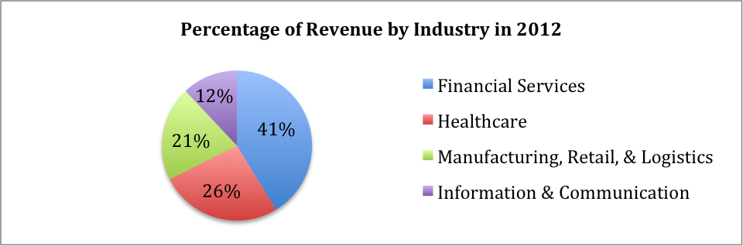

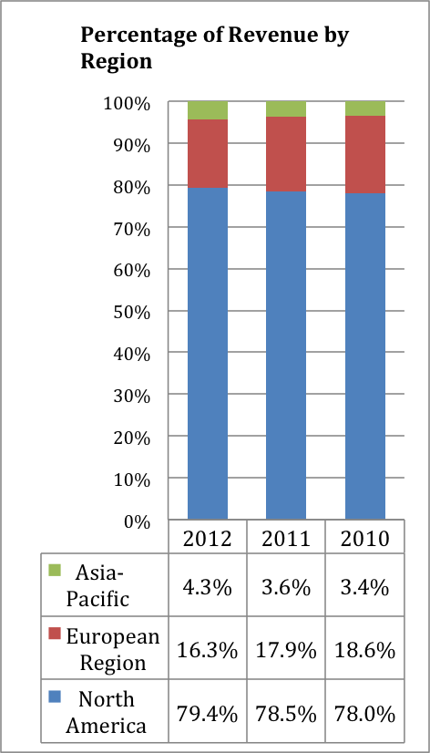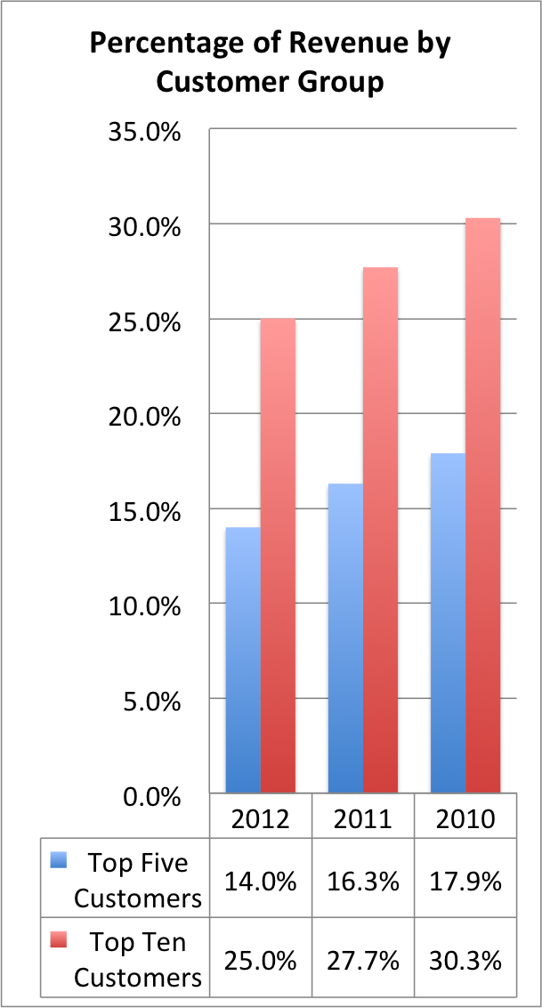

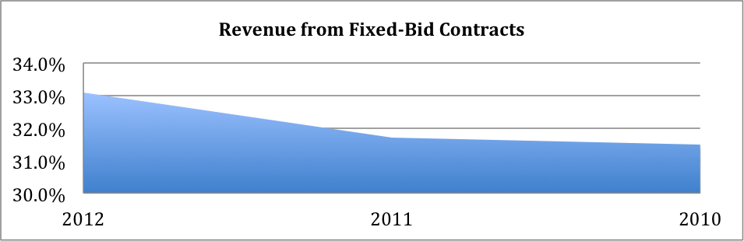

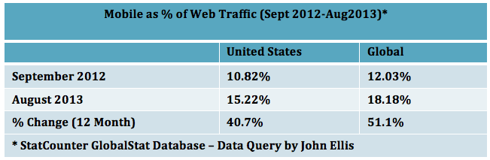



Source: Company Document